DEPT. OF ELECTRICAL & ELECTRONICS ENGINEERING

SRM INSTITUTE OF SCIENCE AND TECHNOLOGY, Kattankulathur – 603 203

|  |
| --- |
| Title of Experiment : **2.VERIFICATION OF** **THEVENIN THEOREMS** |
| Name of the candidate : PONNURI ANIRUDDHA  Register Number : RA2112704010015  Date of Experiment : MARCH 16Th,2022 |

|  |  |  |  |
| --- | --- | --- | --- |
| Sl.  No. | Marks Split up | Maximum marks  (50) | Marks obtained |
| 1 | Pre Lab questions |  |  |
| 2 | Preparation of observation |  |  |
| 3 | Execution of experiment |  |  |
| 4 | Calculation / Evaluation of Result |  |  |
| 5 | Post Lab questions |  |  |
| **Total** | | **15** |  |

Staff Signature

**PRE LAB QUESTIONS**

**1. Define active and passive element.**

**Active and passive components form the two main types of electronic circuit elements. An active component supplies energy to an electric circuit, and hence has the ability to electrically control the flow of charge. A passive component can only receive energy, which it can either dissipate or absorb.**

**2. State Thevenin’s theorem?**

**A complex network consists of linear elements with equal can be reduced to simple circuit consisting single voltage source with a single series resistor**

**3. State Norton’s theorem?**

**Norton's Theorem states that it is possible to simplify any linear circuit, no matter how complex, to an equivalent circuit with just a single current source and parallel resistance connected to a load.**

**4. Difference between dependent and independent sources?**

**Independent Source: It is an active element that provides a specified voltage or current that is completely independent of other circuit variables. Dependent Source: It is an active element in which the source quantity is controlled by another voltage or current in the circuit**

**5. What are the different types of dependent or controlled sources?**

**Voltage-controlled voltage source (VCVS), the current-controlled voltage source (CCVS), the voltage-controlled current source (VCCS), and the current-controlled current source (CCCS).**

|  |  |
| --- | --- |
| **Experiment No. 2**  **Date: MARCH16,2022** | **THEVENIN’S THEOREM** |

**Aim:**

To verify Thevenin’s theorem and to find the full load current for the given circuit.

**Apparatus Required:**

|  |  |  |  |
| --- | --- | --- | --- |
| Sl.No. | Apparatus | Range | Quantity |
| 1 | RPS (regulated power supply) | (0-30V) | 2 |
| 2 | Ammeter | (0-10mA) | 1 |
| 3 | Resistors | 1KΩ, 330Ω | 3,1 |
| 4 | Bread Board | -- | Required |
| 5 | DRB | -- | 1 |

**Statement:**

Any linear bilateral, active two terminal network can be replaced by a equivalent voltage source (VTH). Thevenin’s voltage or VOC in series with looking pack resistance RTH.

**Precautions:**

1. Voltage control knob of RPS should be kept at minimum position.
2. Current control knob of RPS should be kept at maximum position

**Procedure:**

1. Connections are given as per the circuit diagram.
2. Set a particular value of voltage using RPS and note down the corresponding ammeter readings.

**To find VTH**

1. Remove the load resistance and measure the open circuit voltage using multimeter (VTH).

**To find RTH**

1. To find the Thevenin’s resistance, remove the RPS and short circuit it and find the RTH using multimeter.
2. Give the connections for equivalent circuit and set VTH and RTH and note the corresponding ammeter reading.
3. Verify Thevenins theorem.

**Theoretical and Practical Values**

|  |  |  |  |  |  |
| --- | --- | --- | --- | --- | --- |
|  | E(V) | VTH(V) | RTH(Ω) | IL (mA) | |
| Circuit - I | Equivalent Circuit |
| Theoretical | 10 | 4.983 | 495 |  |  |
| Practical | 10 | 5 | 495 | 3.34 | 3.34 |

**Circuit - 1 : To find load current**

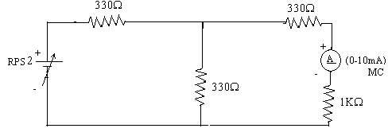

**To find VTH**

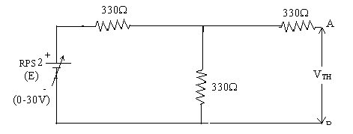

**To find RTH**

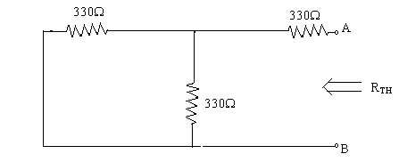

**Thevenin’s Equivalent circuit:**

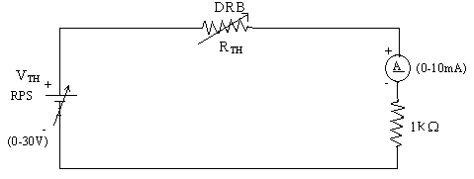

**Model Calculations:**

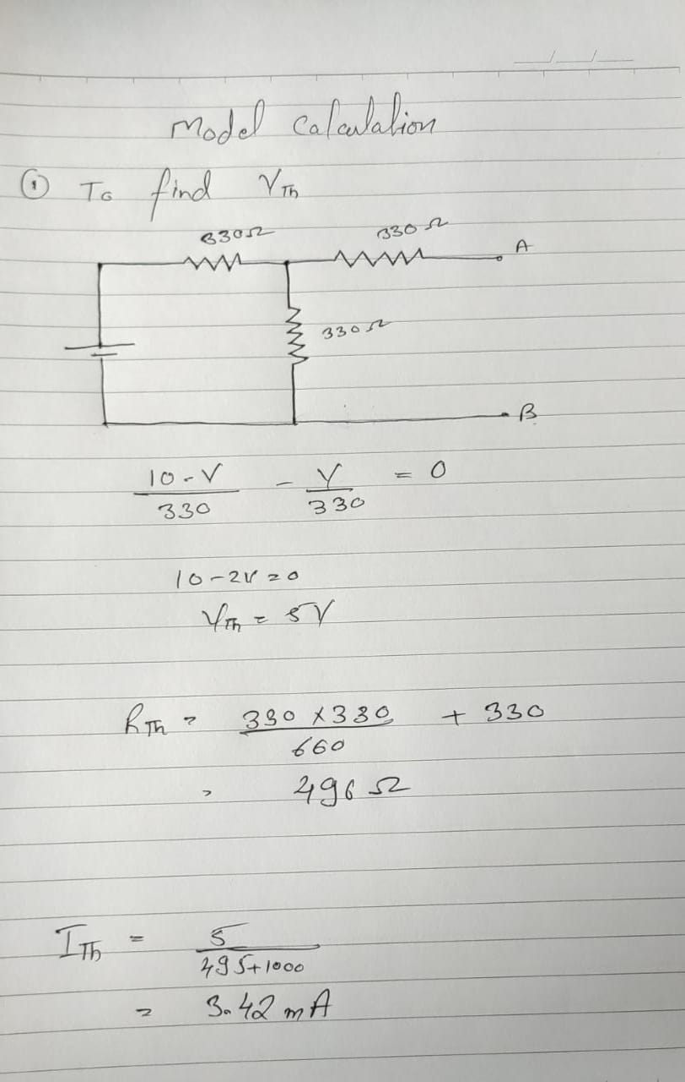

**Simulation output:**

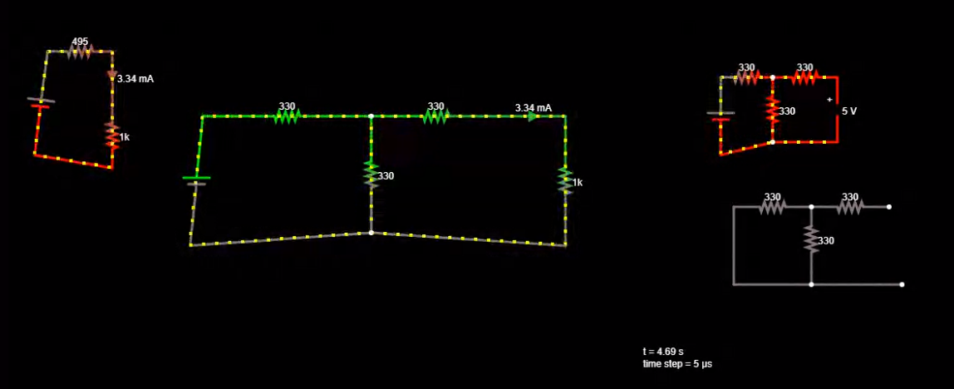

**Result:**

Verified Thevenin’s theorem on the given circuit.

**POST LAB QUESTIONS**

1. **Draw the Thevenin’s equivalent circuit**

